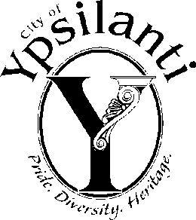
City of Ypsilanti
Police Advisory Commission
One South Huron
Ypsilanti, Michigan 48197

2025 Calendar of Meetings

The City of Ypsilanti Police Advisory Commission meetings for the year 2025 will be held on the fourth Thursday of each month, unless otherwise indicated. Meetings will start at 7:00 PM in the City Hall Council Chambers (first floor) at One South Huron Street, Ypsilanti, Michigan.

January 23rd, 2025
February 27th, 2025
March 27th, 2025
April 24th, 2025
May 22rd, 2025
June 26th, 2025
July 24th, 2025
August 28th, 2025
September 25th, 2025
October 23rd, 2025
November 20th, 2025* (Third Thursday)
(November 20th, 2025 meeting location changed to the downstairs conference room, at city hall, One South Huron Street, Ypsilanti, Michigan)
December 18th, 2025 (Third Thursday)

The City of Ypsilanti encourages persons with disabilities to participate and will provide necessary reasonable auxiliary aids and services, such as signers for the hearing impaired, Limited English Proficiency (LEP) services, and audios of printed materials being considered at the meeting. Individuals requiring auxiliary aids or services should provide two (2) days’ notice to the City, and contact the City by writing or calling the following:

City Clerk’s Office
One South Huron Street
Ypsilanti, Michigan 48197-5420
(734) 483-1100

