
CITY OF YPSILANTI BUILDING DEPARTMENT
The following fees shall be charged for new construction, additions, alterations, and repairs. The determination of value or valuation under any of the provisions of this Code shall be made by the Manager of the Building Department. The valuation to be used in computing the permit fee shall be the total value of all construction work for which the permit is issued, as well as all finish work, painting, roofing, electrical, plumbing, heating, air conditioning, elevators, fire-extinguishing systems and any other permanent work or permanent equipment.

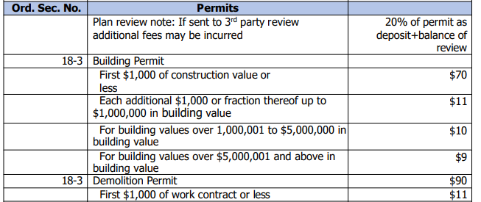

The fee shall be based upon the estimated valuation established by multiplying the square footage of the building (Sq footage of work area for remodels/renovations) by the ICC construction cost valuation table or by other method/methods approved by the Building Official. No permit shall be issued at lesser value than determined by this table or approved by the Building Official.
- ICC table used for both Residential and Commercial would the August 2015 ICC valuation table. Starting April 10th commercial construction would use February 2021 ICC valuation table.
- For remodels and renovations deduct 35%
- Decks, sheds, garages would use Utility/miscellaneous for the cost.

